**Lesson 1-micro:bit voice talk**

****Learning goals:****

This lesson learns to use Python programming to let the micro:bit emit a voice.

**Code：**

from microbit import *

import speech

display.show(Image.HAPPY)

speech.say("Hi, I'm an excellent robot from Yahboom.")

In the program,import speech is means to import the speech library function, use the speech.say function in the library to play "Hi, I'm an excellent robot from Yahboom".

"Hi, I'm an excellent robot from Yahboom" Change to whatever you want to play.

**Programming and downloading：**

1. You should open the Mu software, and enter the code in the edit window, , as shown in Figure 1-1.

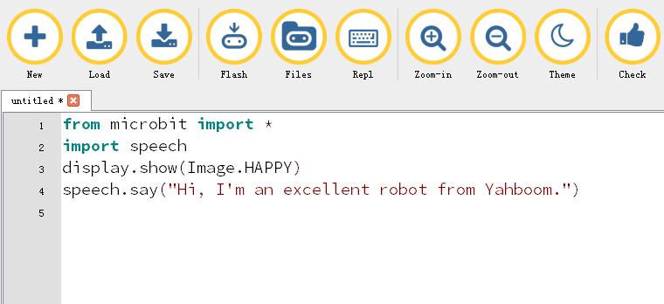

Figure 1-1

2.As shown in Figure 1-2, you need to click the Check button to check if our code has an error. If a line appears with a cursor or an underscore, the program indicating this line is wrong.

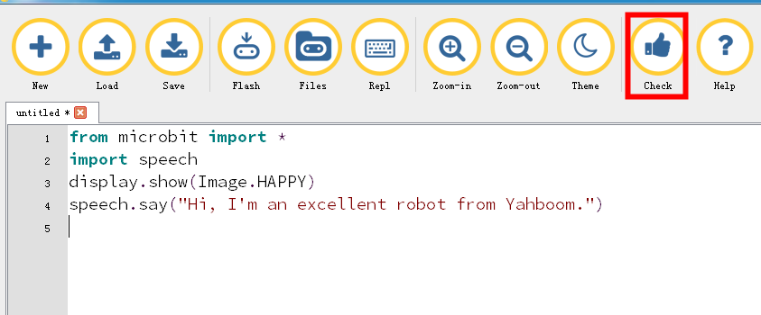

Figure 1-2

3.You need to connect the micro data cable to micro:bit and the computer, then click the Flash button to download the program to micro:bit as shown in Figure 1-3.

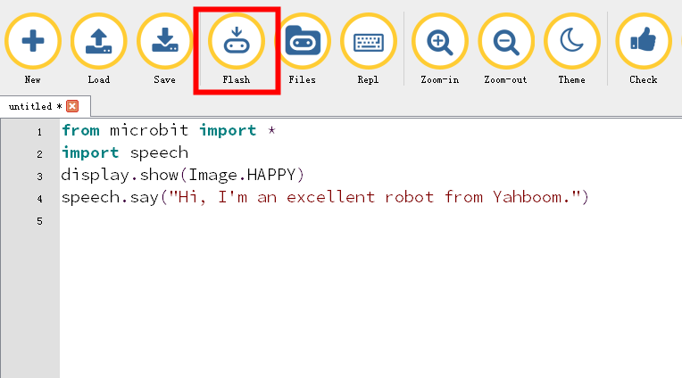

Figure 1-3

4.After the program is downloaded. Press the reset button of the expansion board, you will hear the buzzer say "Hi, I'm an excellent robot from Yahboom." At the same time, the dot matrix screen displays a smile. as shown in Figure 1-4.

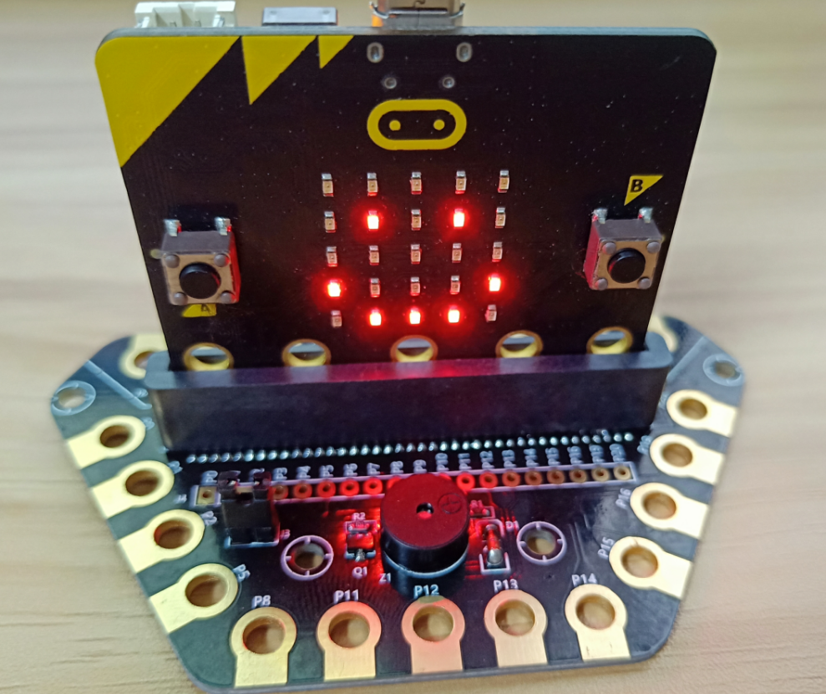

Figure 1-4

Note: There is a headphone jack on the expansion board that can be used to plug in headphones. The buzzer has no sound when the jumper switch is removed.

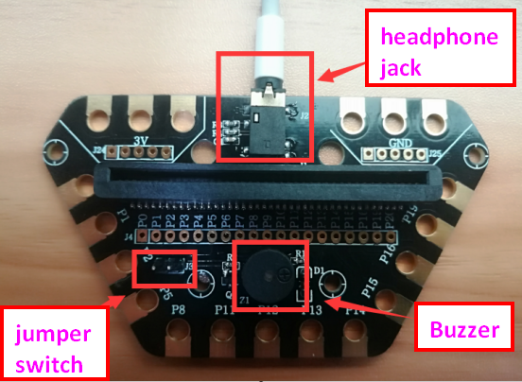

Figure 1-5